**Nama : Nessia Alfadila Putri**

**NIM : 20103061**

**Kelas : S1SI-03-D**

**TUGAS PRAKTIKUM DESAIN PEMROGRAMAN WEB**

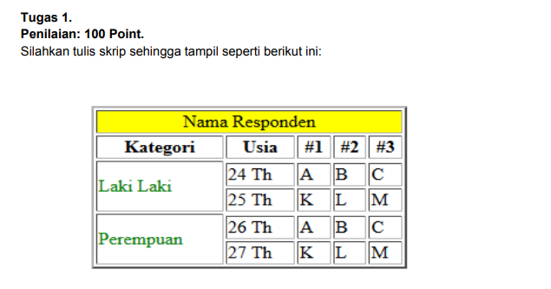

Jawaban :

Source Code :

|  |
| --- |
| Source Code :  <!DOCTYPE html>  <html>  <table border="1" align="center" width="30%">  <tr>  <th colspan="6" bgcolor="yellow" align="center">Nama Responden</th>  </tr>  <tr>  <th>Kategori</th>  <th>Usia</th>  <th>#1</th>  <th>#2</th>  <th>#3</th>  </tr>  <tr>  <td rowspan="3">Laki Laki</td>  </tr>  <tr>  <td>22 Th</td>  <td>A</td>  <td>B</td>  <td>C</td>  </tr>  <tr>  <td>25 Th</td>  <td>K</td>  <td>L</td>  <td>M</td>  </tr>  <tr>  <td rowspan="3">Perempuan</td>  </tr>  <tr>  <td>26 Th</td>  <td>A</td>  <td>B</td>  <td>C</td>  </tr>  <tr>  <td>27 Th</td>  <td>K</td>  <td>L</td>  <td>M</td>  </tr>  </table>  </body>  </html> |

Sreenshoot Output :

